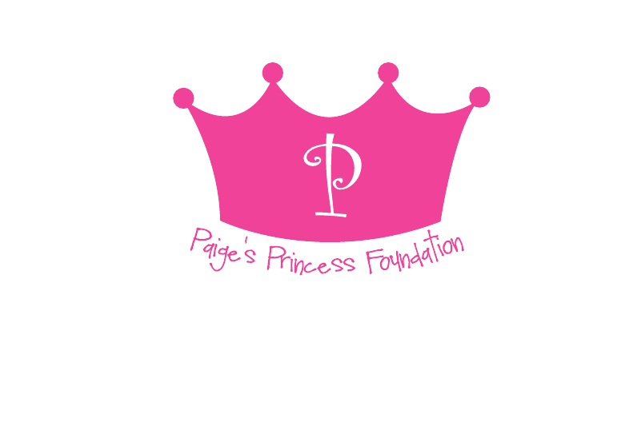
Paige’s Princess Run 5k, June 2, 2018—Wyandot Elementary, Liberty Township, Ohio
_____Platinum ($1,000 and Up)
___Platinum ($1,000 and Up)
• Company name/logo on T-shirts
• Signage at Carnival
• Recognition in selected media
• Recognition in promotional material
• Recognition in on website, social media and newsletter
●5 Run Registrations

_____Gold ($500-$1000)
• Company name on signage at Carnival
• Recognition on selected media
• Recognition in promotional material
• Recognition on website and social media and newsletter
● 3 Run Registrations

• Company name/logo on T-shirts
• Signage at Carnival
• Recognition in selected media
• Recognition in promotional material
• Recognition in on website and social media

_____Silver ($250-$500)
• Recognition on promotional material
• Recognition on website/newsletter
●2 run Registrations

_____Bronze ($100-$250)
• Recognition on website/newsletter
●1 Run Registration

Deadline to ensure full recognition in media/promotional materials including t-shirts: May 2, 2018;
Business Name:_________________________________________________________
Address:_______________________________________________________________
Contact Person:_________________________________________________________
Email: _________________________________________________________________
Thank you for your support!
Paige’s Princess Foundation
Heather Alessandro
Katie Arnold
Kim Bley
Melissa Burleigh
Danielle Gingrich
Wendy Mockabee

Please make checks payable to “Paige’s Princess Foundation” and mail to 912 McBurney Drive, Lebanon, Ohio 45036. Federal Non-Profit Tax ID: 45-2712469

